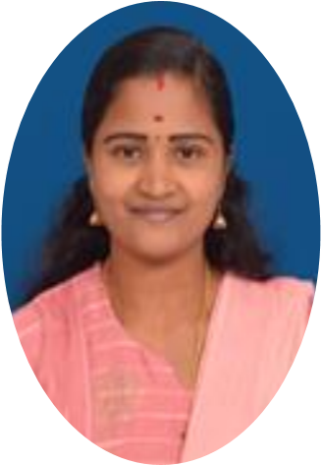

SKILLS
CONTACT
📞7904420211
📧 shinykuttyz95@gmail.com
🔘 No 54-A, Arunachala devar colony
Ramanathapuram-641045
SKILLS
- Good oral and written communication skills
- Ability to prepare audio-visual aids for the students.
- Well versed with Microsoft Word, Excel and PowerPoint.
- Efficient in Internet and basic computer Applications.
- Good in classroom management.

LANGUAGES
- TAMIL
- ENGLISH
- MALAYALAM

CERTIFICATES
- Diploma in Computerized Accounting.
- Certificate in Data Entry.

SHINY PRIYA K

TEACHING ASSISTANT

PROFILE

To begin my Teaching career at an esteemed institution to build strong teacher profile and help students to become globally competitive through developing their skills.

WORK EXPERIENCE
2020 – Working at TIPS GLOBAL INSTITUTION as an Office Administrator.

2018 – Working at Vodafone (VI) office as, office executive.

2017 – Worked at Institution of Cooperative Management (ICM) as, Guest Lecturer of management students.
Responsibilities:
- Preparing lesson plans and developing assignments for the students.
- Preparing visual aids for the students.
- Evaluating performance of the students and maintaining records of them.

ACADEMIC QUALIFICATION
- 2016 - MBA-Finance & Marketing from Kerala University, TVM.
- 2014 – B.COM Kerala University, Trivandrum.

