ASWINI

CONTACT

 dhiyafd85@gmail.com
 917010156775
 14/D Rasipalayam road, Thennapalayam. Coimbatore.

SKILL

English Typerating done in both upper and lower level.
All system based projects

LANGUAGES

Tamil
English
Hindi

OBJECTIVE

To enhance my professional skills, capabilities and knowledge in an organization which recognizes the value of hard work and trusts me with responsibilities and challenges.

EXPERIENCE

10/06/2023 - 08/08/2024 | Ganga Hospital  Billing Assistant and senior supervisor  Cashier and Hr Assistant in management section
02/09/2024 - 20/02/2025 | Ranjan Medical Center  Receptionist and Nursing  Receptionist and senior nurse services

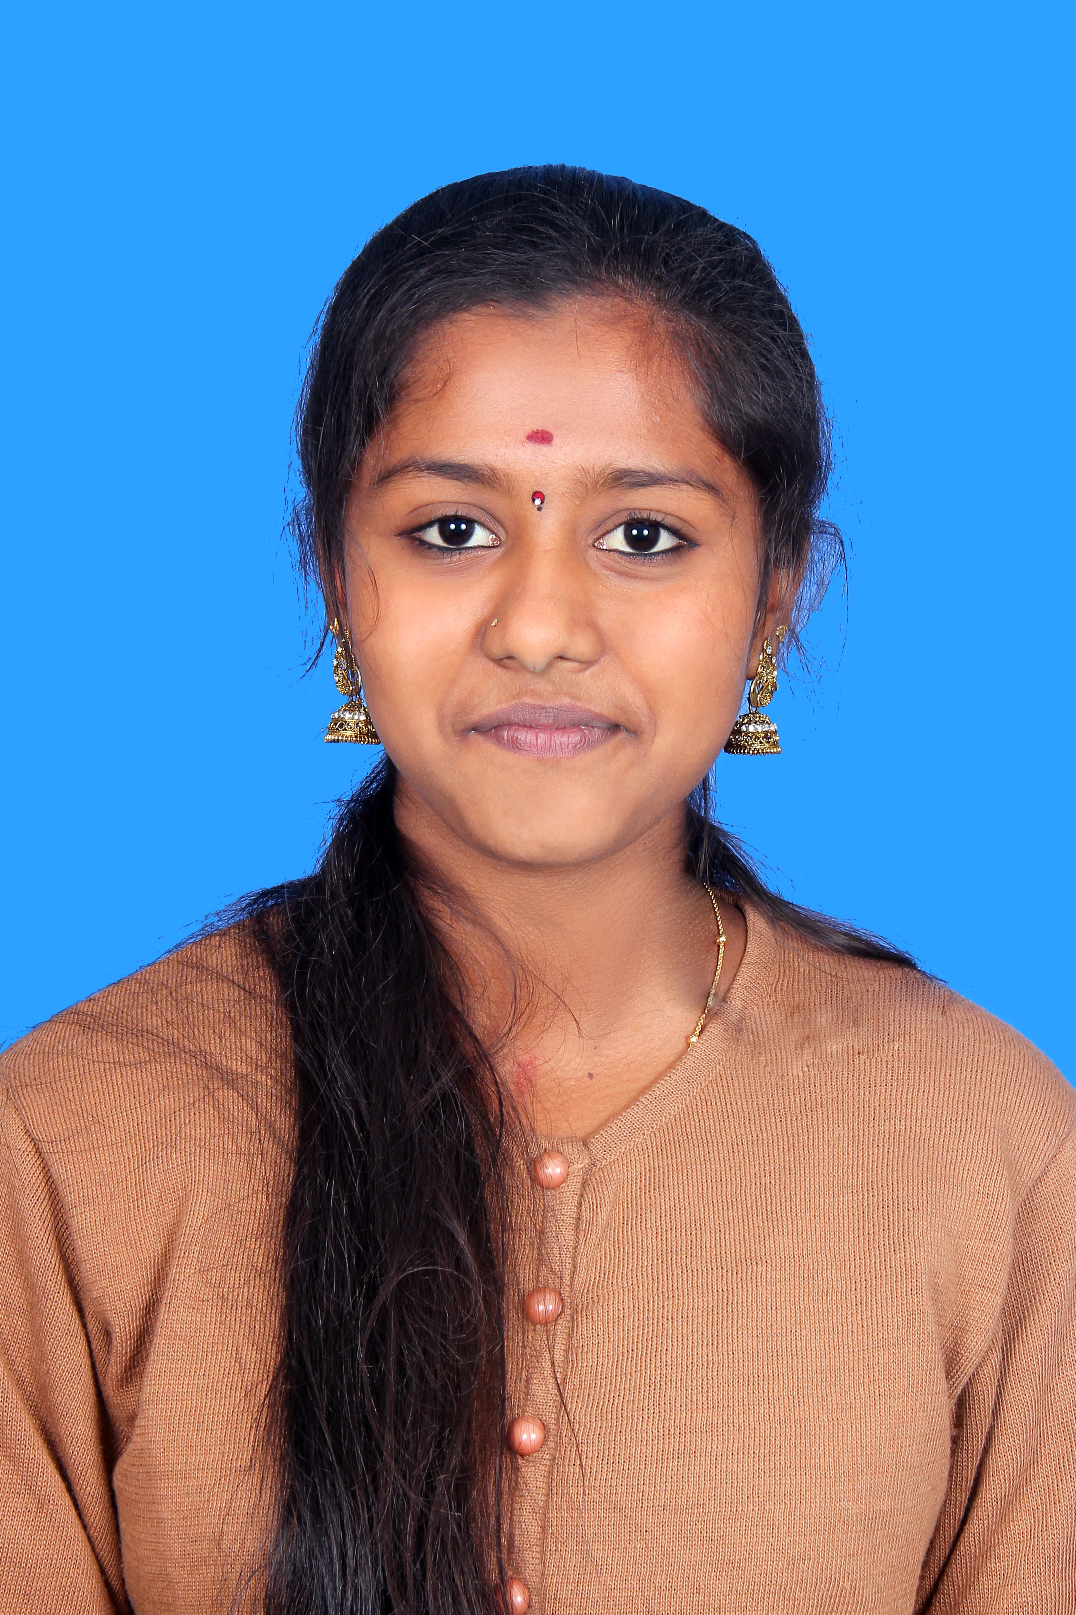

EDUCATION

2023 Government Arts and Science college ,Ooty
B.com CA
87
2020 Sri Shanthi Vijay Girl's Higher secondary school
Hsc
92
2018 Sri Shanthi Vijay Girl's Higher secondary school
Sslc
89

Aswini

