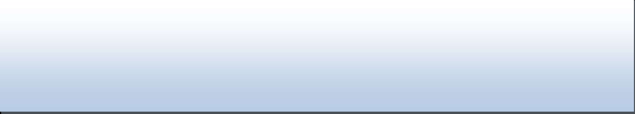
RAJESH MURUGAN
Bachelor of Science in Nursing
Current Address: Valliyoor, Thirunelveli
Phone: +91 9384736121
E-mail: m.rajeshmurugan12@gmail.com

CAREER OBJECTIVE | Career-oriented professional with a proven ability to establish and maintain an effective working environment while fulfilling work obligations. Looking for an organization that will utilize my abilities for my own improvement/growth and  for the benefit of the organization.
PROFESSIONAL QUALIFICATIONS | - ✓ BSC Nursing (2020 to 2024) Bachelor of Science in Nursing, Cherran’s Nursing College. Tellugupalaiyam, Coimbatore.
WORK EXPERIENCE | Stream nursing Foundation – 1 Month  - RMCH Hospital, LIC Colony, Coimbatore.  Stream nursing Foundation – 1 Month  - NG Hospital and Research Center, Singanalore, Coimbatore.  Stream – Community Health Nursing – 1, – 1 Month  - Primary Health care Center. Telungupalayam, Coimbatore  Stream Medical Surgical Nursing – 2, – 1 Month and 1 Week  - Coimbatore Medical College and Hospital, Coimbatore  - Stream Medical Health Nursing– 1 Month and 1 Week  - Coimbatore Medical College and Hospital, Coimbatore.  Stream Medical Health Nursing – 1 Month and 1 Week  - Coimbatore Medical College and Hospital, Coimbatore.  OBG – 2 Months  - Coimbatore Medical College and Hospital, Coimbatore.  Community – 2 Months  - Telugupalaiyam PHC  Internship – 3 Months  - Kalpana Medical Center and Hospital, Coimbatore.
PROFESSIONAL SKILLS | POSSESSING EXTENTIVE KNOWLEDGE IN  -First Aid -IV management  -Patient Condition Monitoring -Patient Examination  -Infection Control -Wound Care  -Patient Education -Pain Management  -Vital signs monitoring -Organizational Skills  -Patient Monitoring -Direct Patient Care  -Injections -Nebulizer  -Oxygen flow meter -Patient Education

LANGUAGE | - English  - Malayalam  - Tamil
PERSONAL PROFILE | Name in Full : Rajesh Murugan  Date of Birth : 12th February 2003  Gender : Male  Civil Status : Un Married  Nationality : Indian
References and Related Documents available upon request

