
JEEJA BHAI K

LOCATION: Bangalore EMAIL ID: JEEJAK05@GMAIL.COM CONTACT NO: +91 8075409049

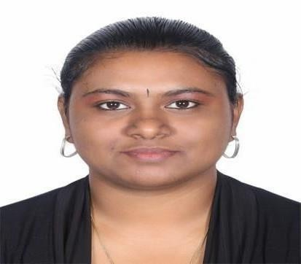
PROFESSIONAL SUMMARY

Customer Relationship Managers are responsible for maximizing customer loyalty and business performance. Their main tasks are analyzing complaints, developing new Customer Care strategies and procedures, creating customer retention campaigns and motivating staff. Those looking to work as Customer Relationship Managers should emphasize in their resumes leadership, communication skills, problem-solving abilities, attention to details and solid Customer Care expertise.
PERSONAL
Permanent
Sukurtham,
Address:
Payyoli Post,
Payyoli, Kozhikode Pin – 673522 Kerala, India.
Father’s Name: Phalgunan k
Husband Name: Sharath Prakash Date of Birth: 05-10-1992
Marital Status: Married
INTERPERSONAL SKILLS
Communication (written and verbal), Detail Customer service, Phone Etiquette Discretion, Responsibility Teamwork and delegation, Flexibility & efficiency
COMPUTER SKILLS
Microsoft Word, Excel, Outlook PowerPoint, SharePoint.
Database Management. Calendar Management.
Internet Enabled Technical Services

WORK EXPERIENCE
PropEx.ai Jan 2024 – Still Working Digital Real Estate Marketplace

RELATIONSHIP MANAGER (COMMERCIAL REAL ESTATE)
Develop relationships with Developer and Investors, End-User Clients.
Establish and maintain strong client relationships, understand their financial needs and objectives, and provide tailored financing solutions
Ensure customer satisfaction and retention by understanding their needs, preferences, and concerns and providing personalized service and support.

CONCORD TOWER AT DUBAI Nov 2021 – Nov 2023

SALES MANAGER (REAL ESTATE)
Advances the community and customer experience through online and traditional marketing
Responsible for the effective and professional handling of all customer interactions via outgoing sales call to offer products at regular and special prices to increase sales volume

Markets presentations and product demonstrations, as well as negotiating contracts with potential clients.

Updates knowledge of sales related legal documentation and property management, as well as updating and managing social media profiles
Keep records and reports up to date & Organize and schedule meeting and events


HDFC LIFE INSURANCE AT KOZHIKODE Nov 2020 – Nov 2021 CORPORATE AGENCY MANAGER (BANCASSURANCE)
- Signing on new clients and helping them through the onboarding process.
- Managing client bank accounts, including opening and closing accounts, and overseeing transactions.
- Processing deposits, payments, and withdrawals.
- Authorizing and evaluating overdrafts and loans.
- Handling other transactions, such as writing cashier checks or money orders, when necessary.
- Recommending and explaining banking services and products to clients based on their needs.
- Presenting and cross-selling banking services and products to existing and prospective clients.
- Collaborating with other banking professionals to ensure high-quality client service.
- Resolving client queries and complaints. Performing administrative and clerical duties, such as data entry and filing, when

MAXLIFE INSURANCECO AT KANNUR Oct 2017- Sep 2020

CUSTOMER RELATIONS MANAGER
  - Overseeing the relationship with customers handled by your team.
  - Resolving customer complaints quickly and efficiently.
  - Keeping customers updated on the latest products in order to increase sales.
  - Meeting with managers in the organization to plan strategically.
  - Understanding key customer individual needs and addressing these.
  - Building and maintaining profitable relationships with key customers



KOTAK MAHINDRA BANK AT KOZHIKODE May 2016-Jul 2017

ASSISTANT SALES MANAGER
- Continually meeting or exceeding sales quotas.

- Monitoring the performance of the sales team.
- Building and maintaining good working relationships with customers.
- Identifying opportunities and strategies to increase sales.

- Regularly attending sales meetings and training sessions.

- Performing all duties of the Sales Manager in cases of absence.

EDUCATION

MBA: MYSORE UNIVERSITY /BANGALORE / 2015
Dual Specialization in MBA Marketing and Supply Chain Management.
BBA: CALICUT UNIVERSITY /KOZHIKODE / 2013
I did my graduation BBA Regular course.

UNDERGRADUATE: G.V.H.S. School Kozhikode / 2010

I HEREBY DECLARE THAT ALL DATA ABOVE FURNISHED ARE BEST OF MY KNOWLEDGE AND BELIEF.

JEEJA BHAI K

