CURRICULUM VITAE
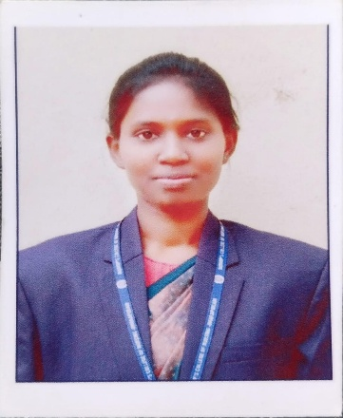
S.P. ASHEEBA,
D/0 A.Sundar singh,
5/148-Purakulam, Vazhukkamparai,
Suchindrum (post), kanyakumari
629704.
Mail ID: spasheeba@gmail.com.
Contact No : 638579180.
OBJECTIVE:
To work in a medical facility where my nursing profession is an advantage in catering quality health care and humanitarian service to its general clientele.
To seek a nursing position where professional along with personal skills can help maximize spiritual growth in the service of God and Humanity, in dedication to my work.
ACADEMIC PROFILE:
Courses | School/College | Board/  University | Percentage
SSLC | St Tresa’s Matric Hr Sec School ,Vazhukkamparai. | State Board | 71%
HSC | St Tresa’s Matric Hr Sec  School,Vazhukkamparai. | State Board | 58%
B.Sc  (Nursing) | Bishop’s College of  Nursing,Dharapuram. | Tamilnadu  Dr.M.G.R.Medical  University | 1st Year - 80 %  2nd Year – 62 %  3rd Year - 67%

TRAINING UNDERGONE HOSPITALS:
- Government Hospital, Dharapuram.
- CSI Mission Hospital ,Trichy.
- Erode Cancer Institute ,Erode .
- Government Hospital,Trippur.
- Kasturba Hospital, Gandhigram.
- CSI Annie Booth Mission Hospital,Dharapuram.
WORKSHOPS AND SEMINARS:

- Participated in National Conference of “OUR NURSES OUR FUTURE : STRENTHENING AND INVESTING IN NURSING RESEARCH TO ENHANCE EVIDENCE BASED PRACTICE “

- Participated in BASIC LIFE SUPPORT (CPR and AED) PROGRAM conducted by AMERICAN HEART ASSOCIATION.

- Participated in National conference of “ “HOLISTIC NURSING CARE ON CONGENITAL ANOMALIES”.

RESEARCH PROJECT:
PROJECT TITLE:
A Study to assess the knowledge regarding tuberculosis and it’s management among II nd year bsc nursing students Bishop’s college of nursing , Dharapuram.

PERSONAL DETAILS:

Father’s Name : Sundar singh.A
Date of Birth : 18-01-2003
Age : 22 years
Gender : Female
Nationality : Indian
Marital status : Unmarried
Language Known : Tamil , English
Educational Qualification : Bsc., Nursing

DECLARATION:
I hereby declare that the above furnished information are true to the right of my knowledge and belief.
I would be in honor to work for your institution. Thanking you,
Yours Faithfully,

(S P ASHEEBA )

